**17. Release Records**

--- **note** - In this lecture, I will briefly introduce you to how Helm maintains the release records as secrets in the kubernetes cluster.

# List the secrets in kubernetes

--- kubectl get secrets

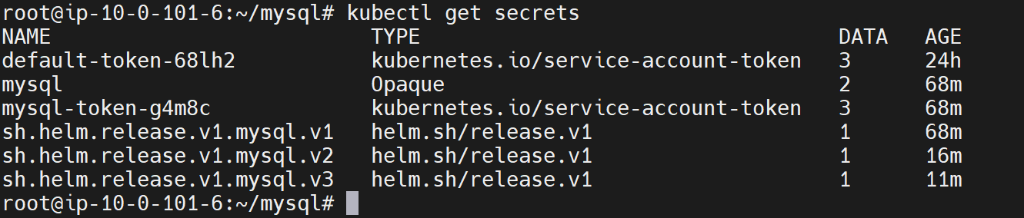

--- **note** - you can see there are two secrets for the MySQL installation we have done through helm and there are 3 more secrets for the same installation for each version. when we first installed MySQL package using helm.

--- This got created and then other secret got created when we upgraded the application. Every time we do an upgrade. It will create a secret here, and this is nothing but a release record. This secret record will have the entire information about that installation.

--- That is how helm maintains the record data will revisit this again when we learn about rollbacks.